**High Level Design Documentation**

Big Game Census Data Visualization

Revision Number: 1.0

Last date of revision: 08/06/2023

# -SUJITH REDDY

# Document Version Control

|  |  |  |  |
| --- | --- | --- | --- |
| **Date Issued** | **Version** | **Description** | **Author** |
| **8th JUNE 2023** | 1.0 | First Version of Complete HLD | SUJITH REDDY |
|  |  |  |  |
|  |  |  |  |
|  |  |  |  |
|  |  |  |  |
|  |  |  |  |
|  |  |  |  |

# Contents

Document Version Control 2

Abstract 4

1. Introduction 5
2. General Description 6
   1. Product Perspective & Problem Statement 6
   2. Tools used 6
3. Design Details 7
   1. Functional Architecture 7
   2. Optimization 8
4. KPIs 9
   1. KPIs (Key Performance Indicators) 9
5. Deployment 10

# Abstract:

The recently released Big Game Census data visualization @(<https://www.census.gov/library/visualizations/interactive/big-game-census.html>) includes player data (from Yahoo Sports: <https://sports.yahoo.com/nfl/teams/>) and U.S. Census Bureau Population Estimates data for incorporated places and states, vintage 2016 and 2017, respectively.

This Big Game Census data visualization takes a fun look at where Super Bowl 52 players come from, the related population figures, and opens up pathways (via embedded links) to additional census data points.The Big Game Census looks at Super Bowl players and their birthplaces, and gives you access to related population data

Did you know that this game also features players from 32 different states, one island territory, and three countries? The Big Game Census interactive visualization takes a closer look at the players’ hometowns, and gives you access to Census data points for those places. If you have not decided which team you are pulling for this Sunday, maybe you’ll find a connection to your state or your hometown that will help you decide.

# 1 Introduction

Big Game Census data visualization project utilizes three separate excel data files which are used simultaneously to extract relevant information and portray the same.

The visualization shows the following details:

* Is someone from your hometown in the game?
* All States with Number of Players, Players Teams & Average Player Age
* All Teams with their Avg. Player Age, Avg. Years Played, Median Player Weight
* Player Birthplace with its 2016 Population Estimates

The given data is visualized on powerbi Desktop .The dashboard given below can be accessed using the link:

# General Description

## Product Perspective & Problem Statement

Big Game Data is used here which allows us to draw insights about the players, teams, states with most players, average age of players, average years played, median weight, player birthplace, player colleges, top performing players. These insights are of great interest for game enthusiasts, team supporters, fans of the players, etc.

The objective of the project is to perform data visualization techniques to understand the insight of the data. This project aims apply various Business Intelligence tools such as Tableauor Power BI to get a visual understanding of the data.

## Tools used

Business Intelligence tools used in this project are :





Microsoft Excel is used for storing and preprocessing data.

POWERBI Desktop is used to visualize the data with the help of different kinds of visualizations available on it such as Treemap, Bubble Chart, Bar Chart, Maps, Bar Chart, Line Chart, etc.

These visualizations are then displayed together on the dashboard .

Python is used in backend coding.

# Design Details

## Functional Architecture

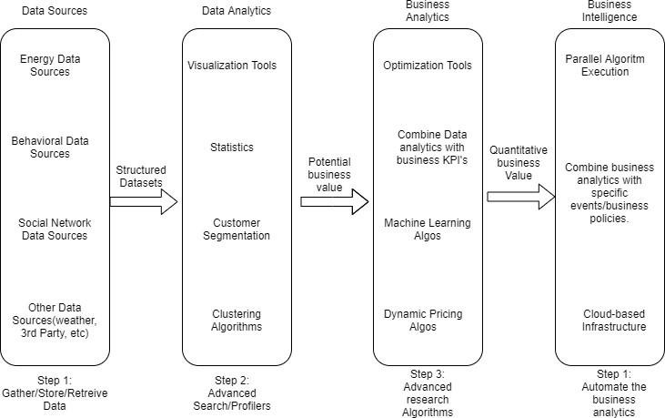

Figure 1: Functional Architecture of Business Intelligence

* 1. Optimization

Your data strategy drives performance

* + - Minimize the number of fields
    - Minimize the number of records
    - Optimize extracts to speed up future queries by materializing calculations, removingcolumns and the use of accelerated views

Reduce the marks (data points) in your view

* Practice guided analytics. There’s no need to fit everything you plan to show in a singleview. Compile related views and connect them with action filters to travel from overviewto highly-granular views at the speed of thought.
* Remove unneeded dimensions from the detail shelf.
* Explore. Try displaying your data in different types of views. Limit your filters by number and type
  + Reduce the number of filters in use. Excessive filters on a view will create a more complex query, which takes longer to return results. Double-check your filters and remove any that aren’t necessary.
  + Use an include filter. Exclude filters load the entire domain of a dimension, while include filters do not. An include filter runs much faster than an exclude filter, especiallyfor dimensions with many members.
  + [Use a continuous date filter](http://onlinehelp.tableau.com/current/pro/online/mac/en-us/help.htm#filtering_add_dragfields_dates.html). Continuous date filters (relative and range-of-date filters)can take advantage of the indexing properties in your database and are faster than discrete date filters.
  + [Use Boolean or numeric filters](http://www.tableau.com/learn/tutorials/on-demand/logical-calculations). Computers process integers and Booleans (t/f) much faster than strings.
  + Use [parameters](http://onlinehelp.tableau.com/current/pro/online/en-us/help.htm#parameters.html) and [action filters](http://onlinehelp.tableau.com/current/pro/online/en-us/help.htm#actions.html). These reduce the query load (and work across datasources). Optimize and materialize your calculations
    - Perform calculations in the database
    - Reduce the number of nested calculations.
    - Reduce the granularity of LOD or table calculations in the view. The more granularthe calculation, the longer it takes.
      * LODs - Look at the number of unique dimension members in the calculation.
      * Table Calculations - the more marks in the view, the longer it will take tocalculate.
    - [Where possible, use MIN or MAX instead of AVG](http://onlinehelp.tableau.com/current/pro/online/windows/en-us/help.htm#calculations_aggregation.html). AVG requires more processingthan MIN or MAX. Often rows will be duplicated and display the same result with MIN, MAX, or AVG.
    - [Make groups with calculations](http://kb.tableau.com/articles/knowledgebase/creating-groups-using-calculated-fields). Like include filters, calculated groups load only named members of the domain, whereas Tableau’s group function loads the entiredomain.

# KPIs

Dashboards will be implemented to display and indicate certain KPIs and relevant indicators for the disease.



As and when, the system starts to capture the historical/periodic data for a user, the dashboards will be included to display charts over time with progress on various indicators orfactors

## KPIs (Key Performance Indicators)

Key indicators displaying a summary of the Housing Price and its relationship with different metrics

1. Is someone from your hometown in the game?
2. All States with Number of Players, Players Teams & Average Player Age
3. All Teams with their Avg. Player Age, Avg. Years Played, Median Player Weight
4. Player Birthplace with its 2016 Population Estimates

# Deployment

With the explosive growth of enterprise data, database technologies, and the high demand for analytical skills, today’s most effective IT organizations have shifted their focus to enabling self-service by deploying and operating Tableau at scale, as well as organizing, orchestrating,and unifying disparate sources of data for business users and experts alike to author and consume content.

Tableau prioritizes choice in flexibility to fit, rather than dictate, your enterprise architecture. Tableau Server and Tableau Online leverage your existing technology investments and integrate into your IT infrastructure to provide a self-service, modern analytics platform for yourusers. With on-premises, cloud, and hosted options, there is a version of Tableau to match your requirements. Below is a comparison of the three types:

TYPE PROS CONS

### Powerbi Server - On Premises

* Full control of hardware and software
* Infrastructure and data remain behind your firewall
* Need dedicated administrators to manage hardware and software
* Additional infrastructure needed to access off-network (mobile, external)

### powerbi Server - Public Cloud (IaaS)

* Full control of software on managed hardware
* Puts infrastructure in same place as data (for migration to cloud)
* Flexibility to spin up/down hardware as needed
* Need dedicated administrators to manage software
* Additional infrastructure needed to access off-network (mobile, external)

### powerbi Online (SaaS)

* Fully hosted solution (hardware, software upgrades)
* Fast to deploy
* Easy for external audience to access
* Single-site in multi-tenant environment
* Cubes are not supported
* No guest account access

Depending on your organizational roles and responsibilities, Powerbi Server should be installed by a systems administrator and the designated powerbi Server Administrator in coordination with the appropriate IT roles. For powerbi Online, you will integrate with your existing technology and configure the site settings. The Data & Analytics Survey, completed by business teams, identifies and prioritizes data use cases, audience size, and users. You will use the information collected in both surveys to plan your deployment strategy, including sizing, installation, and configuration of your powerbi Server or integration and configuration of powerbi Online. In addition to installing powerbi Server or configuring powerbi Online, administrators will also need to plan for the client software installation of powerbi Prep Builder, powerbi Desktop, powerbi Mobile, and powerbi Bridge for powerbi Online where applicable.